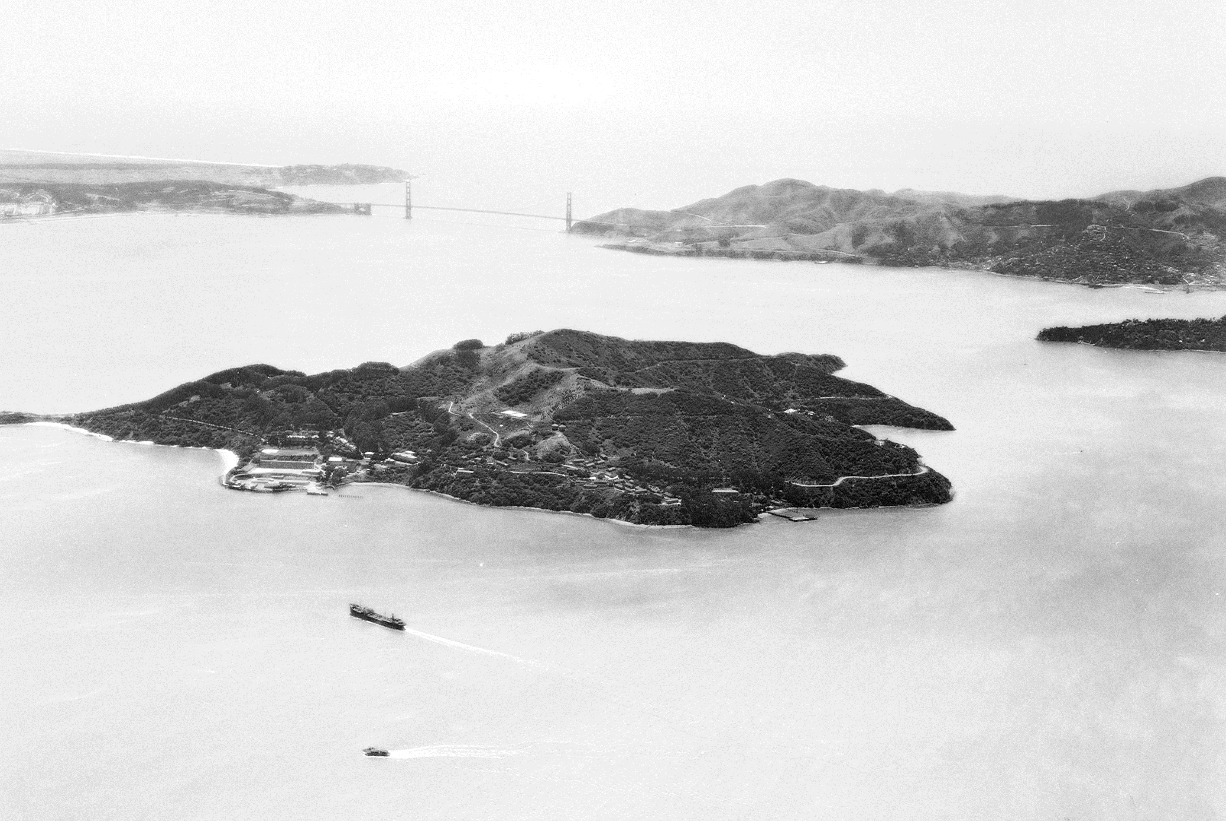**Cub Scout Fun Day - Angel Island Hike**

**Saturday, November 4, 2017**

Sponsored by Troop 73 | Venture Crew 512

Join Boy Scouts from Troop 73 and Venture Scouts from Crew 512 on a beautiful 5-mile hike around Angel Island. The experienced Scouts will help Cub Scouts with map and compass reading skills, pointing out wildlife, and other valuable Scout skills. Compasses will be provided if needed. **All family members are welcome!**

The trip starts and ends at the Alameda Main Street Ferry Terminal. Be there at 8:45 AM to catch the 9:10 ferry. There will be a quick change of ferries at Pier 41 in San Francisco. After a great day hiking, we will return to Alameda via Pier 41, arriving at 3:50 PM.

The only cost for the trip is for the ferry rides.

$30 for adults; $23 for youth 12-18; $16 for youth 5-11.

Prices approximate and are dependent upon use of Clipper Cards, etc.

Tickets may be purchased online or purchased aboard the ferry.

**Reminders:**

1. Scouts should wear their Cub Scout uniform or Scout t-shirt. Dress in layers.
2. Wear appropriate hiking footwear
3. Bring plenty of water, lunch and a healthy snack
4. If you have a compass you would like to bring, please do so.
5. Preapply sunscreen and bring extra to reapply

**Questions?** Contact Mike Panos, Scoutmaster Troop 73 [mcpanos@yahoo.com](mailto:cafreck@gmail.com)