JANUARY PACK MEETING: CAKE BOSS (Pg. 1)  HAIGHT MPR  TUESDAY, JAN. 17 | SNOW CLOTHES  SWAP (Pg. 2)  JANUARY PACK MEETING TUESDAY, JAN. 17 | 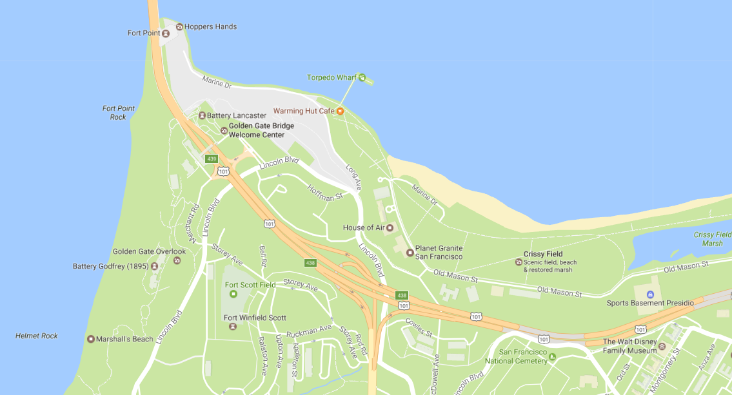  JANUARY PACK HIKE  (Pg. 3)  PRESIDIO HISTORIC TRAIL SF  SAT., JAN. 14, NOON – 3PM | MONSTER JAM (Pg. 4)  O.CO COLISEUM  SATURDAY, FEB. 18
The Bugler. Newsletter of Pack 1015
Jan. Pack Meeting: Cake Boss & Snow Clothes Swap
IN THIS ISSUE
Cake Boss Pack Meeting 1
Snow Clothes Swap 2
Upcoming Events 2
Presidio Trail Pack Hike 3
Pinewood Derby Cut-Out 4
Monster Jam 4
Cubmaster’s Corner 5
Volunteers Needed! 5
Friends of Scouting 6
Back by popular demand, the January Pack Meeting will feature our 3nd Annual Cake Boss Fundraiser!! For those of you new to Pack 1015, our Cake Boss competition is an annual event where Cub Scouts use their creativity and baking skills to create an entry in the Pack’s cake auction. This is one of our biggest fundraising events of the year, crucial to raising the additional funds needed to meet our budget and provide a quality Scouting Program. Cake Boss has been a huge success the past two years!!
What Scouts need to do: Plan, prepare, make, and decorate a cake to bring to the Pack meeting. Many Packs do the same fundraiser, so the internet is full of great ideas and example images. Our theme this year is Alameda. Scouts can run with this theme in many ways: “What do you love about Alameda?”; “What’s your favorite place in Alameda?”; “What makes Alameda unique?” or “What is the most Alamedan thing about Alameda?” Be creative and have fun!
Speaker Presentation: This year we’re honored to have a special guest back again, local celebrity cake maker Henry Awayan of Whisk Cake Creations (www.whiskcakecreations.com). Henry will provide a cake decorating demo of an original cake creation, which will then be auctioned-off live during the meeting.
Silent Auction: Throughout the meeting, all attendees are welcome to tour the room to view and bid on their favorite cakes. The starting bid will be $20 and will go up in increments of $5. All payments are due at checkout, so please remember your checkbook.
Buy-it-Now option: We’re offering the “Buy-it-Now!” option again this year, where you can bypass the bidding war and walk away with your cake – at your convenience thanks to express checkout – for the flat rate of $75 a cake.
Prizes: All scouts who bring a cake will receive a special patch (to be awarded at their next Den meeting)!! In addition, three Cake Boss winners will be selected by Henry Awayan for best-in-show and awarded a special Cake Boss prize. Henry will be judging for creativity!
- WHEN? Tuesday, Jan. 17th, Cake registration starts 6:15pm; Flag Ceremony at 7:30pm
- WHERE? Haight Elementary School MPR (2025 Santa Clara Ave.)
- QUESTIONS? Email flashfoot@gmail.com for more info
2017 Snow Clothes Swap!
UPCOMING EVENTS
PRESIDIO TRAIL HIKE
Saturday Jan. 14, 12:00pm
Presidio Visitor Center, SF
CAKE BOSS PACK MEETING
Tuesday Jan. 17, 6:15pm
Haight Elementary School
(Includes Snow Clothes Swap)
USS PAMPANITO
Fri-Sat, Jan. 20-21
SOLD OUT
BSA CRAB FEED
Saturday, Jan. 21, 6pm
St. Philip Neri Church Alameda
PINEWOOD CUT-OUT
Tuesday, Jan. 24, 7pm
Earhart MPR
(Optional Troop 3 event)
WINTER LODGE TAHOE
Fri-Sun, Feb. 3-5
SOLD OUT
MONSTER JAM
Saturday, Feb. 18, 7pm
O.co Coliseum
(Pit Party 3-5:45pm)
PINEWOOD DERBY
Friday, Feb. 24, 6:30pm
Haight MPR
See http://pack1015.org/calendar-of-events/pack-events-calendar/ for a complete and up-to-date calendar of events, including Den meetings.

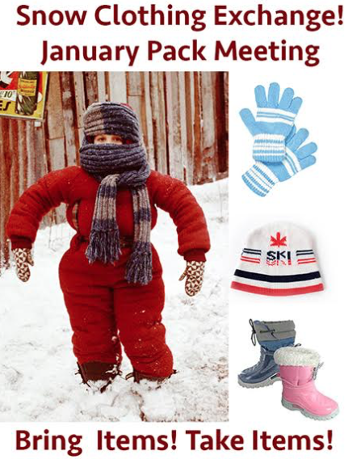
Did your favorite little snowperson grow a lot over the past year? Well, get ready for snow at Winter Camp by bringing any outgrown or un-needed snow clothes (boots, bibs, gloves, and jackets for either gender) to the 9th Annual Pack 1015 Snow Clothes Swap to be held at the Cake Boss Pack meeting, and exchange for better fitting threads. Even if you don't have anything to bring but find something you need, you are welcome to it - this is a 'have a snow gear, give a snow gear; need a snow gear, take a snow gear' event. Tables will be set up in the back of the Pack meeting with clothes laid out by type – please come by the meeting early to add your own gear and browse what's available before Cake Boss begins. Let it snow!
- WHEN? Tuesday, Jan. 17th, 6:30pm (during January “Cake Boss” Pack Meeting)
- WHERE? Haight Elementary School MPR (2025 Santa Clara Ave.)
- QUESTIONS? Contact Gordon at flashfoot@gmail.com
January Pack Hike: Presidio Historic Trail, SF
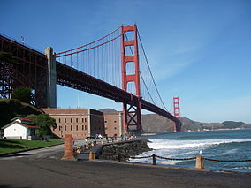
Unfortunately, conditions are too wet for us to safely do the Rock City hike on Saturday, as originally planned. But we can still shake off the cabin fever and get outdoors with our friends! Our January hike will take us to the Presidio Golden Gate Historic Trail in San Francisco. This 3.5 mile hike features beautiful bay views and plenty of San Francisco history. We’ll explore the base of the Golden Gate Bridge, Fort Point, the National Cemetery, and other historic sites around the Presidio.
This hike counts toward Pack 1015’s Golden Boot award. Scouts who complete this hike will also earn a special patch designed specifically for the Presidio Historic Trail by the San Francisco Bay Area Council – don’t miss out on this opportunity to decorate your Pack 1015 sweatshirt!
IMPORTANT: We’ll be riding the Presidio’s free shuttle bus to the starting point, and hiking back to our cars. Since there is a capacity limit on the shuttle bus, YOU MUST RSVP for this hike. The first 25 people to RSVP (Group 1) will board the 12 noon shuttle bus with me. Group 2 will board the 12:30pm bus and hike with Cubmaster Gordon.
To RSVP, email Kim (see below) and/or fill out the Google Form provided at https://docs.google.com/forms/d/e/1FAIpQLSfFkF6Jfre8kAGLO-Kvj99cTMeAyvuHYsQtqYqagZs-04EflQ/viewform.
- WHEN? Saturday, Jan. 14th, 12pm – 3pm; SHUTTLE BUSES DEPART at 12:00pm and 12:30pm
- WHERE? Meet at 105 Montgomery Street, Presidio, San Francisco
- QUESTIONS? Email kimrankin@gmail.com

Pinewood Derby Cut-Out with Troop 3
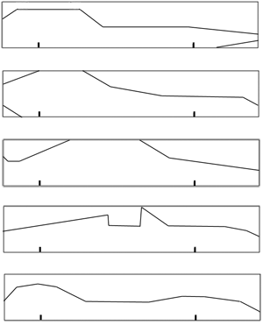
Due to popular demand, Troop 3 has graciously agreed to offer a second Pinewood cutout session open to Cub Scouts. The Pinewood construction can be difficult without the proper equipment (e.g., a band saw). It can even be difficult with the proper equipment, so it wouldn’t hurt to come regardless, especially if this is your first Pinewood Derby, to learn some tips and tricks from Scouts and adult leaders who have done this before. Remember to bring your Pinewood kits (the block itself at least); kits were handed out at last month’s Pack meeting. If you missed the December Pack Meeting, you can pick up your PWD kit at the January Pack Meeting.
Note: this is a Troop 3 sponsored event. To help Troop 3 get an idea of how many Cub Scouts they will be accommodating, please RSVP to Carlos Flores at info@pack1015.org. Also come early to watch the Boy Scouts conduct their flag ceremony – this will be a great learning experience for our kids.
- WHEN? Tuesday, Jan. 24, 7:00pm
- WHERE? Earhart Elementary School MPR (400 Packet Landing Rd, Bay Farm)
- QUESTIONS? Email info@pack1015.org

Monster Jam: Sign up NOW!
Monster Jam returns to Oakland next month with more monster trucks than ever before! Shows consist of numerous elements, including head-to-head racing, donuts & wheelies, and of course the freestyle competition, which gives trucks the chance to run wild – attempting crowd pleasing sky wheelies, cyclone style donuts, possible roll-overs, and much more! For more info and to sign up, check your email inbox for “2017 MONSTER JAM at O.co Coliseum sign up form” or use the Google Form provided at:
https://docs.google.com/forms/d/e/1FAIpQLSeJs948uGfNW-VJPgIX5DJw7JS0dYuUTCUzm6G0sjRVhFpVNg/viewform?c=0&w=1&usp=mail_form_link
Sign-up by end of day Monday, January 16th!
Pit Party. Pit passes are $5.00 each. Weather permitting, the Pit Party occurs from 3 pm to 5:45 pm. This fabulous event provides fans with the opportunity to meet drivers, take photographs, perhaps even get autographs, and see Monster Trucks up close and personal! For details, visit the MJ website. See below for the basics:
- WHEN? Saturday, Feb. 18, 7pm (optional Pit Party 3pm – 5:45pm)
- WHERE? O.co Coliseum
- COST? $17 per person (adults and kids), extra $5 per person for Pit Party pass
- QUESTIONS? Email info@pack1015.org

Cubmaster’s Corner
Sunshine is delicious, rain is refreshing, wind braces us up, snow is exhilarating; there is really no such thing as bad weather, only different kinds of good weather. - John Ruskin
Happy New Year! I hope everyone had a great winter break and found ways to enjoy the many inches of rain we received the past few weeks. While we dry out, get psyched for all the Pack 1015 events coming up in the next few weeks: Presidio Hike; Cake Boss; USS Pampanito Overnight; Winter Lodge; and the Pinewood Derby.
Also, we would like to extend thanks to all of our many volunteers that make Pack 1015 so active and fun, especially: Joan DeWindt for playing piano at the December Pack Meeting; Kim Rankin for organizing the Presidio Historic Trail Hike; Kathy Choi for being the Pack Treasurer and for coordinating the Cake Boss Check Out; Anna Williams for coordinating the Winter Clothes Exchange; Carlos Flores for coordinating with Troop 3 to get another PWD cutout event (and for being a rockstar with the million other things he does with the Pack as Committee Chair!); Kara Eastwood for coordinating the upcoming overnight on the USS Pampanito; Chris Kelly and Stacey Plaskett for coordinating the Winter Lodge signups; Laura Katz, Emily Anne Schulte, and Nicole Mendez for coordinating the Winter Lodge events; Matt Brotze for coordinating Monster Jam event; and Richard Haick for taking on a new role as co-Sports Event Coordinator with Matt Brotze. In addition, thank you to all of the Den Leaders and Pack Leaders who keep things running! When you see these people around, please take a moment to say “Thank you!”
~Gordon Williams, Cubmaster

Additional Info

Volunteering for Pack 1015
Pack 1015 is 100% volunteer staffed, and we are constantly in need of new and additional volunteers to help coordinate the many activities we do during the year. Time commitments can be as little as just a few hours to plan one event. We have a truly great Pack, and this is because of the voluntary contributions of the parents who step up and take on a small part of the coordination effort. The volunteer positions listed below need to be filled in order to continue to offer these activities to our Scouts:
- More Winter Lodge Volunteers: We need pretty much everyone going to winter lodge to help out in some capacity; please step up to help when asked!
- Summer Car Camping Event Coordinator: We need someone to take on the Summer Overnight Camping Event. This will be a two-night car-camping style event with the location and dates to be determined. Responsible for reserving the spot, coordinating signups, and coordinating the food. This volunteer get to help choose the destination!
- Pack Treasurer: We will need a new Pack Treasurer starting at the end of this school year. This role involves coordinating the Pack budget, handling the reimbursements, and tracking Pack expenditures. This is great for anyone who loves numbers (any CPA’s out there?)
- Bugler Editor-in-Chief: We need a new Bugler Editor staring at the end of this year. Approx. time required: 4-6 hours per edition, 6-8 editions per year ideally. This volunteer will be shadowing the current and outgoing Bugler editor, takes sole responsibility for Bugler as of summer 2017.
- Room Coordinator: This person is responsible for booking all of the rooms for Pack and Den meetings. The bulk of the reservations are made in the summer, and there are occasional changes to handle throughout the year. This job is almost entirely on e-mail.
INTERESTED? Please contact our Committee Chair, Carlos Flores. Carlos can be reached at info@pack1015.org. Thank you!

Alameda Council Annual Crab Feed and Auction

The Alameda Council is holding its 8th Annual Crab Feed & Auction on January 21, 2017. This event will draw Scouts from all Packs and Troops in Alameda and, as such, is a great opportunity for Pack 1015 families to make new friends! Dinner starts at 6pm and will be followed by both silent and live auctions. Please note that tickets will not be sold at the door. Register online by going to http://www.bsa-alameda.org/EventRegistration.aspx?e=262&rs=14.

Friends of Scouting
Help grow big things with the Boy Scouts of America. Donate to the Alameda Council and give young people the chance to have fun, gain confidence, and become leaders who live by the Scout Oath and the Scout Law.
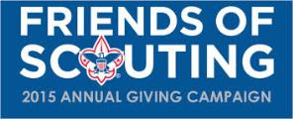
Financial resources for Alameda Council come from our Friends of Scouting (FOS) annual giving campaign, foundation grants, special events, product sales, and income from invested assets. You can help us close the gap by going to http://www.bsa-alameda.org/Donate and choosing a contribution amount you are comfortable with. The Scouts thank you!

